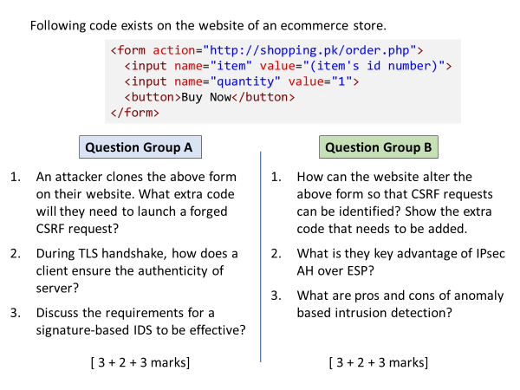

A

1

<script> document.forms[0].submit(); </script>

above code line causes the form to auto submit. Alternatively, they can also submit the form in response to a user action (e.g. click on a different button)

2

Server shares its public key certificate to client, which client can check if valid, it treats the server as authentic.

3

* Signatures database should be sufficiently large
* Signatures are continuously updated with the new attack patterns.

B

1

add a hidden field containing STP token as its value

<input type=”hidden” name=”token” value=”(STP token)” />

2

AH coverage includes the IP packer header, while ESP protects the payload only.

3

Pros: recognize new/novel attacks for which signatures haven’t been collected

Cons: high rate of false positives.